European Civilizational Immune Refugee Policy Framework

Author: Kong Weicheng (孔维程)

Affiliation: Independent Researcher, Founder of Civilization Immune Theory，Founder of Nine Civilizational Axioms

Date: 2025

License: CC0 1.0 (Public Domain Dedication)

1. Core Objectives

• Safeguard Europe’s core civilizational values of love and freedom.

• Identify and admit high-CHS (high Civilization Health Score) individuals, while restricting the spread of high-negative CHS (structurally cancerous) individuals.

• Combine individual freedom of movement with a civilization-level immune system to prevent structural contamination.

⸻

2. Core Principles

1. Function First Principle

• Prioritize admission of individuals with high FFI (Functional Fabric Index) and high CHS as “functional cells” for the civilization.

2. Structural Risk Defense Principle

• Apply entry quarantine or outright denial for individuals with high CSI (Cancerous Structure Index) and high-negative CHS.

3. Convertibility Principle

• Offer cultural integration and civilizational adaptation programs for individuals with neutral or slightly negative CHS.

4. Long-Term Tracking Principle

• Implement continuous CHS monitoring post-entry to prevent low-CHS groups from forming reverse-unification structures in Europe.

⸻

3. Operational Model

3.1 Pre-entry Screening

• Use the CHS model to quantify refugees:

• FFI (Functional Fabric Index)

• CSI (Cancerous Structure Index)

• CHS (Net Civilizational Health Score)

• Conduct scoring via interviews, background checks, social media analysis, and AI-based semantic evaluation.

3.2 Classification & Diversion

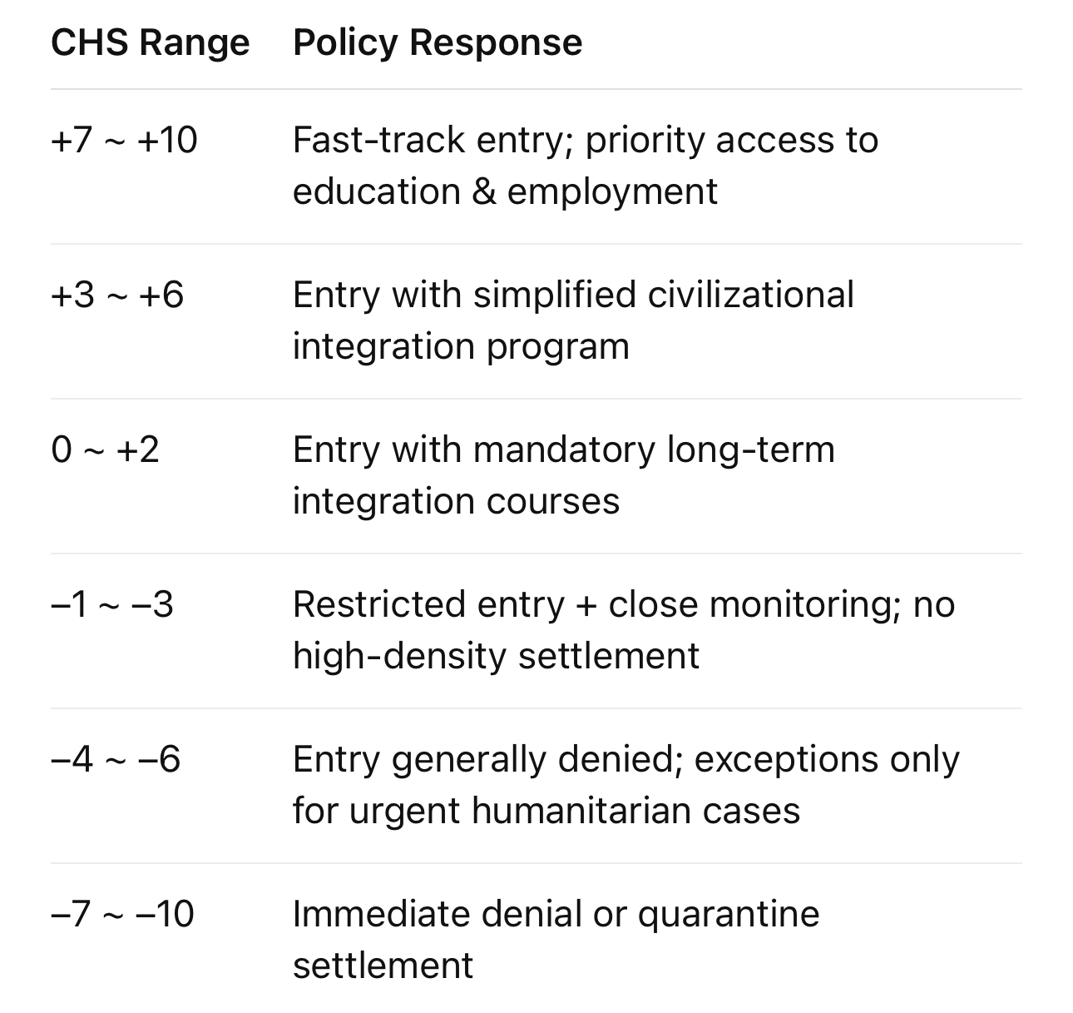

3.3 Integration & Immunity

• High CHS → Assign to key sectors and community leadership roles.

• Medium CHS → Provide intensive language, law, and cooperation culture training.

• Low CHS → Pair with “civilization mentors” (high-CHS individuals) to prevent isolated cultural enclaves.

3.4 Dynamic Evaluation

• Reassess CHS every 1–2 years to adjust residency status.

• For individuals with significant CHS decline and structural risks, limit their societal influence.

⸻

4. Crisis Response Mechanisms

1. Structural Contamination Quarantine

• If high-negative CHS groups form reverse-unification structures, dismantle and disperse them, or deport core actors.

2. Civilization Immunity Education

• Promote civilizational core values and immune awareness in schools and local communities for all new arrivals.

3. International Cooperation

• Share CHS databases with other free civilizational states to build a global civilization immune network.

⸻

5. Final Goal

• Shift refugee policy from “passive reception” to “precision civilizational enhancement + risk isolation”.

• Build the world’s first Civilizational Immune Migration Management System, ensuring Europe’s free structures remain sustainable.

⸻

If we look at the refugee issue through the Civilization Health Check model, Europe must avoid a drop in CHS (civilization health) while keeping the civilization immune system open—without closing itself off out of fear. I’d approach it in three stages:

⸻

1. Front-End Screening: CHS Filtering Before Entry

• Functional Identification – Rapidly assess each individual’s FFI (Functional Fabric Index) and CSI (Cancerous Structure Index) using educational background, behavior history, social media activity, language use, and political attitudes.

• Structural Immunity Threshold – Ensure entrants have a CSI below a set limit (e.g., ≤ 4.0) to prevent large-scale inflow of high-spread, negative-CHS individuals.

• Regional Diversion – High-CHS individuals get priority entry into core society; low-CHS individuals first enter transition and adaptation zones for value-orientation and social structure training.

⸻

2. Mid-Term Transformation: The “Metabolic” Function of the Civilizational Immune System

• Cultural Absorption & Structural Reshaping – Expose refugees to European legal frameworks, values of freedom, and collaborative social mechanisms—so they are not sealed inside their original, closed communities.

• Lifestyle Map Upgrade – Guide them toward high-CHS living environments (safe water, free socialization, healthy information sources) to reduce the risk of reverse assimilation by low-CHS enclaves.

• Language & Narrative Training – Build their capacity for civilizational expression, enabling healthy participation in public discourse instead of importing structuralized hatred or obedience culture.

⸻

3. Long-Term Defense: Civilizational Immunity and Reverse-Unification Prevention

• Dynamic Check-ups – Reassess CHS levels in migrant populations every 2–3 years, triggering targeted intervention or transformation programs when high-risk trends appear.

• Preventing Reverse Unification – Stop certain groups from forming “structural enclaves” inside Europe that transplant original power structures into the host society—currently Europe’s largest hidden risk.

• Global Cooperation – Share the Civilization Health Check database with other high-CHS countries so “structural contamination sources” are identified before they reappear in different states.

⸻

✅ Expected Outcomes:

• Europe retains its high-CHS civilizational core without slow internal erosion.

• Genuine high-CHS refugees gain faster and deeper integration opportunities, becoming net contributors to civilization.

• Low-CHS individuals also have a path to transformation, but without endangering public systems before that process is complete.

**Appendix A: CHS Classification Standards (-10 ~ +10)**

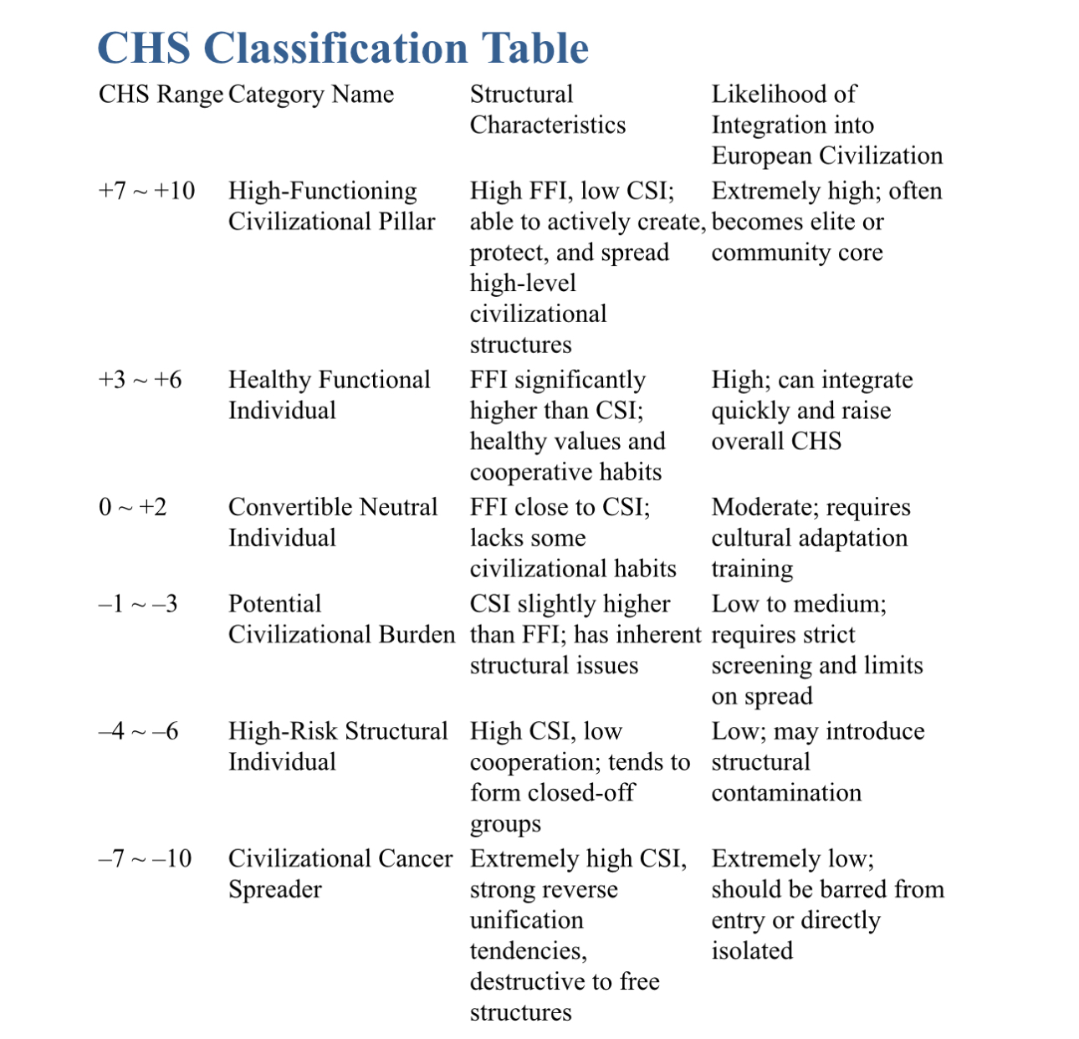

Key Points for CHS Interpretation

1. FFI > CSI → Positive CHS – The individual has a net positive contribution to the health of civilization.

2. FFI ≈ CSI → CHS near zero – Structurally neutral; likely to be shaped by the surrounding environment.

3. CSI > FFI → Negative CHS – The individual will consume or erode existing civilizational structures.

4. Absolute CHS magnitude – A large absolute value means stability in that role:

• Large positive → stable creator/contributor.

• Large negative → stable destroyer/eroder.

• Near zero → unstable, easily influenced by the environment.

⸻

Application to European Refugee Screening

• Direct Acceptance – CHS ≥ +3

• Conditional Acceptance + Transformation Program – CHS between 0 and +2

• High-Risk Observation or Rejection – CHS ≤ –1

**Appendix B: CHS Distribution Map of Refugee Source Countries**

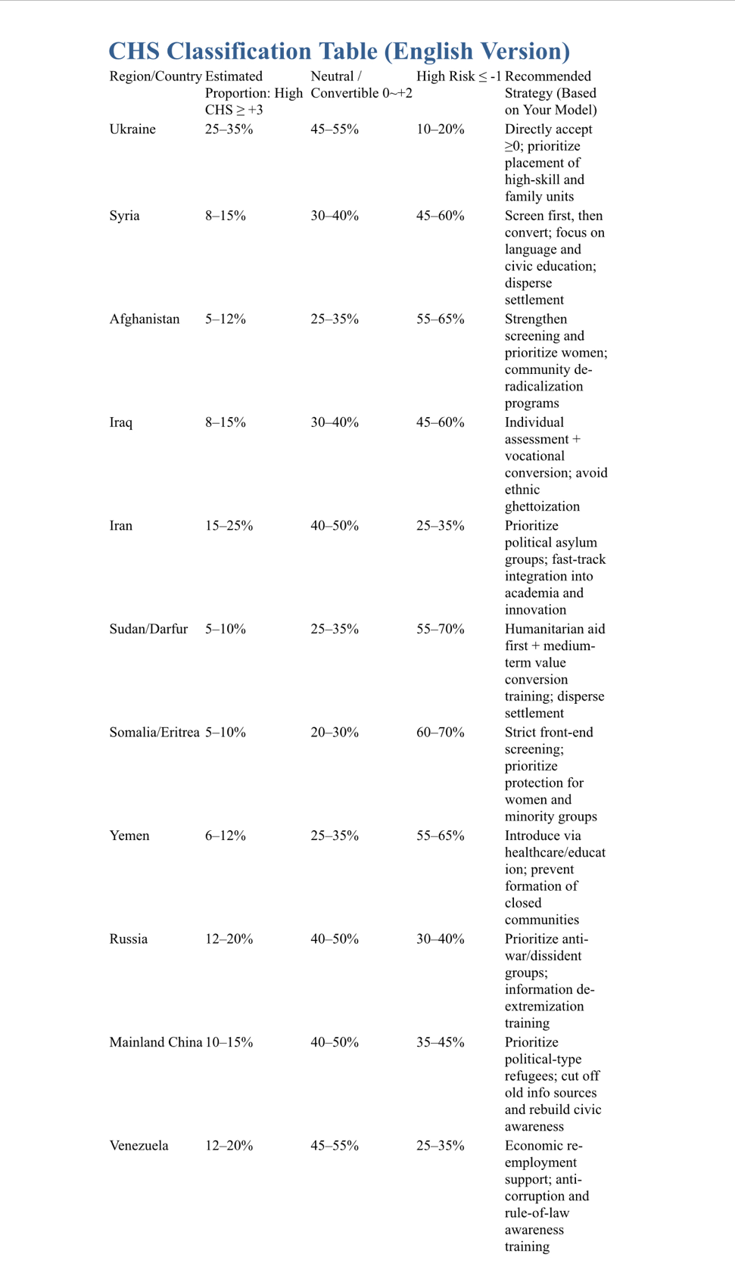

──────────────────────────────

──────────────────────────────

──────────────────────────────

🌍 Civilization Corpus · 文明全集

Author: Wei Cheng Kong (WK 孔维程)

License: CC0 1.0 Universal (Public Domain Dedication)

🔗 Permanent Mirrors · 永久镜像

- GitHub Pages (Master Entry):

https://wk-26.github.io/Civilization-Axioms-and-Immune-System-/

- GitHub Repository:

https://github.com/wk-26/Civilization-Axioms-and-Immune-System-

- Internet Archive:

https://archive.org/details/a-new-civilization-for-humanity-cc-0

- Zenodo (DOI, all versions):

https://doi.org/10.5281/zenodo.16980277

For any existence to endure, it must recognize and embody the first eight axioms.

任何存在若要延续，必须承认并吸纳前八大公理。

Refusal leads to cancerization and destruction.

拒绝承认者，必然走向癌化与毁灭。

──────────────────────────────